OFFICIAL COORDINATION REQUEST FOR
NON-ROUTINE OPERATIONS AND MAINTENANCE

COORDINATION TITLE- 12BON36 BON Spillway rock removal.
COORDINATION DATE- 4 October 2012
PROJECT- Bonneville Dam
RESPONSE DATE- 11 October 2012

Description of the problem- Contract has been awarded to repair erosion holes in the Bonneville Spillway. Currently no special operations are required. A daily conference call will occur at 1:30 between RCC, BPA, Bonneville Project, Construction Office and the Contractor to inform the contractor of expected conditions for the next 24 hours, 48 hours etc. If the contractor has any special request it will be discussed during the conference call.

Emergency spill procedures are in place/documented in the Plans and Specs but the goal is to not have to spill during the contract.

Currently trying to negotiate an early start date to be able to have the contractor remove rocks from the stilling basin. Contractor could move in as early as 22 October but no later than 1 November. Work will take up the majority of the in-water work window.

Type of outage required- BON spillway, except Bays 1 and 18 which are used for attraction flow, will be out of service about a week earlier than previously coordinated.

Impact on facility operation- The spillway will be out of service for an additional week. Avian wires will need to be removed a week earlier than originally planned.

Dates of impacts/repairs- As early at 22 October 2012.

Length of time for repairs- Possibly up to a week for rock removal. Spillway repair then begins on 1 November.

Expected impacts on fish passage
Downstream migrants- No impacts expected.

Upstream migrants- There may be impacts to upstream migrating salmonids and lamprey, using the Cascades Island fishway entrance (B-Branch will likely remain OOS during this operation). Impacts are likely to be noise disturbance associated with the rock removal.

Even with these impacts, removing the rock is a critical step in repairing the spillway.

Table 1. Average fish (Chinook, steelhead, coho, chum) passage at BON from 22 – 31 October 2007 -2011.
Date | 10/22 | 10/23 | 10/24 | 10/25 | 10/26 | 10/27 | 10/28 | 10/29 | 10/30 | 10/31
Average passage | 1874 | 1378 | 1336 | 1059 | 883 | 1166 | 821 | 716 | 825 | 712

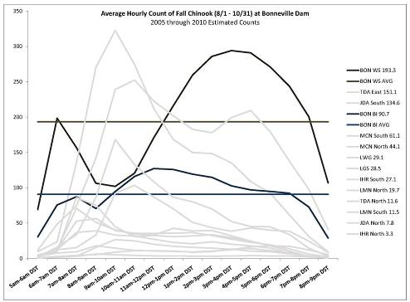
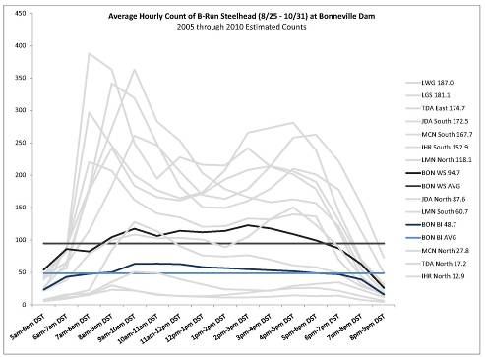
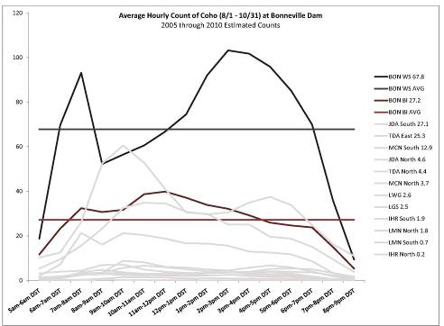
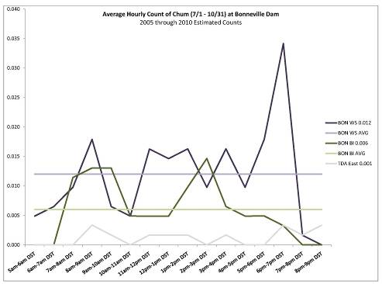
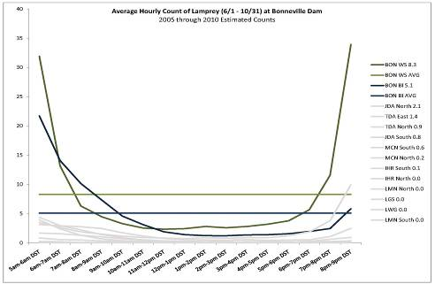

Comments from agencies
04 October 2012 NWP FFDRWG- The FFDRWG attendees were in favor of getting the rocks removed and recommended this request go to the 11 October 2012 FPOM.

11 October 2012 FPOM.- Approved.

Final results- This action will move forward as coordinated.

Please email or call with questions or concerns.
Thank you,
Jon Rerecich and Tammy Mackey

